PCB Construction pt 2 – August 8, 2019

1. Source Article <http://www.technoblogy.com/show?2FCL> - Includes a through hole PCB for panel mounting.
2. Reference files on GitHub - <https://github.com/JohnGENZ/ZL3TILProject>
3. Circuit Diagram [Function Generator Circuit Diagram](functiongenerator.gif)

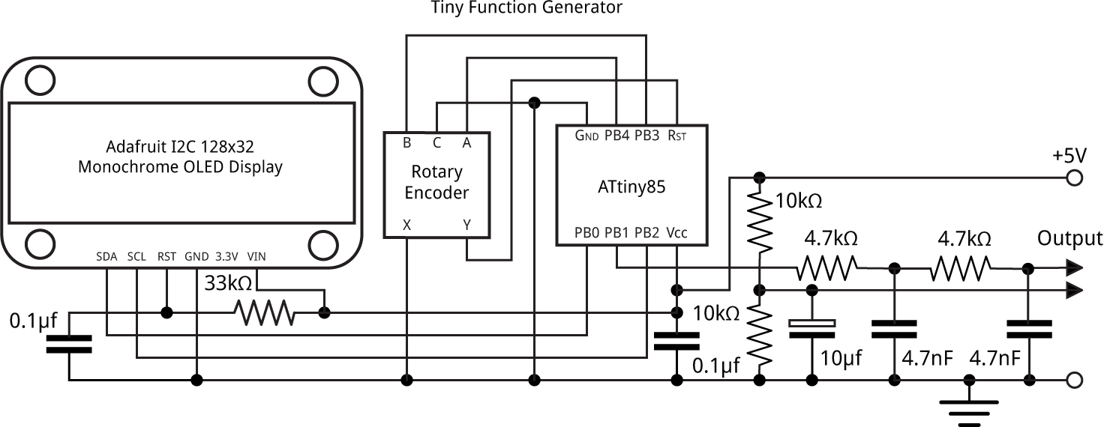

1. Recap
   1. Software selection – worked with the free version of Eagle
   2. Talked about SMD components and how it helps to choose the components as early as possible in the design process
   3. Demonstrated key aspects of board layout using Eagle.
   4. Ended up with a single sided and double sided layout – this is the double sided board:

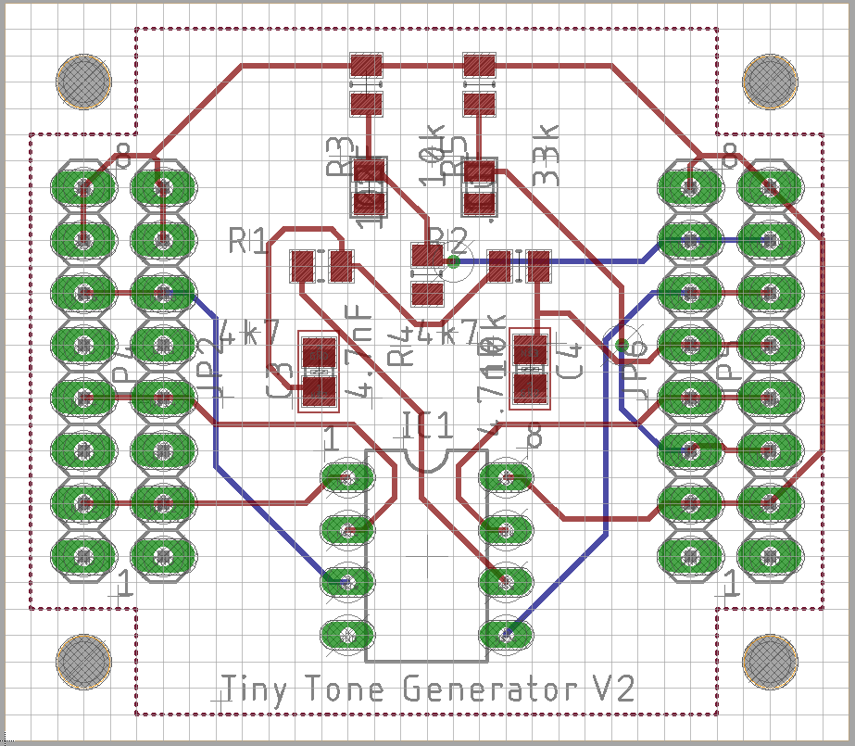

1. Tonight:
   1. Design Rules – the bit left out last time
   2. Generate a Bill of Materials
   3. Making the board yourself
   4. Options for getting a board made
2. Design Rules:
3. These are the rules that govern how the board can be made.
4. Most typically they relate to the capability of the fabricator or the fabrication process. The answer is different if you want to mill a board, or hand drill it, or it may depend on how you apply the resist. They may also relate to the electrical properties of the circuit – maybe for current carrying or rf performance.

Eg <http://support.seeedstudio.com/knowledgebase/articles/447362-fusion-pcb-specification>

1. Don’t use minimum values unless you really must. 6mil spacing and 10 mil traces are very small! 0.5mm is probably the smallest dimension for milling.
2. default JGE Seeed V6 10mil Trace free.dru is a modified version of the Eagle default files for use with the free version of Eagle (2 layers).

Seeed Video: <https://youtu.be/xi_zk9OG1R0>

1. Generate a Bill of Materials
   1. Start EAGLE
   2. Select the schematic and choose ULP
   3. Run bom – probably the first option
   4. Save values and .csv to disk
   5. Import .csv in to Excell (does not work if you just open it)
   6. Example files are ToneGeneratorSMD_V1viii BOM.csv for the export from Eagle, and Eagle BOM 31 March 19.xlsx for the resulting .xls file.
   7. Build the BOM for Seeed. See the template Seeed BOM Template 2018.xlsx
   8. Template Seeed BOM (Seeed BOM Template 2018.xlsx)
   9. Bom exported from your drawing (Eagle BOM 31 March 19.xlsx)
   10. Start with the Seeed template to build a BOM for Seed. You need the component designator and quantity from the bom exported from your drawing (Eagle BOM 31 March19.xlsx) and the Manufacturer’s part number and link from the Mouser basket.
   11. The result will be a Seed BOM that looks like Seeed BOM 31 March 2019i.xlsx
2. Making the board yourself
   1. Fabrication - alternative resist methods and chemical etch.
   2. Assembly

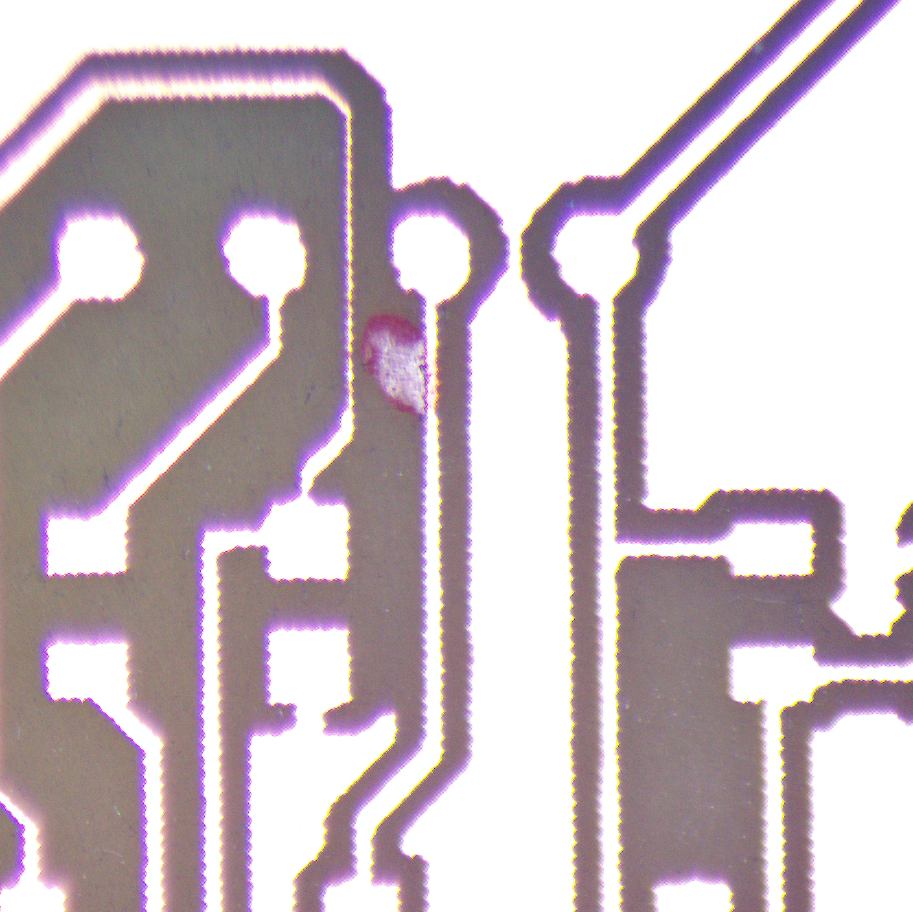

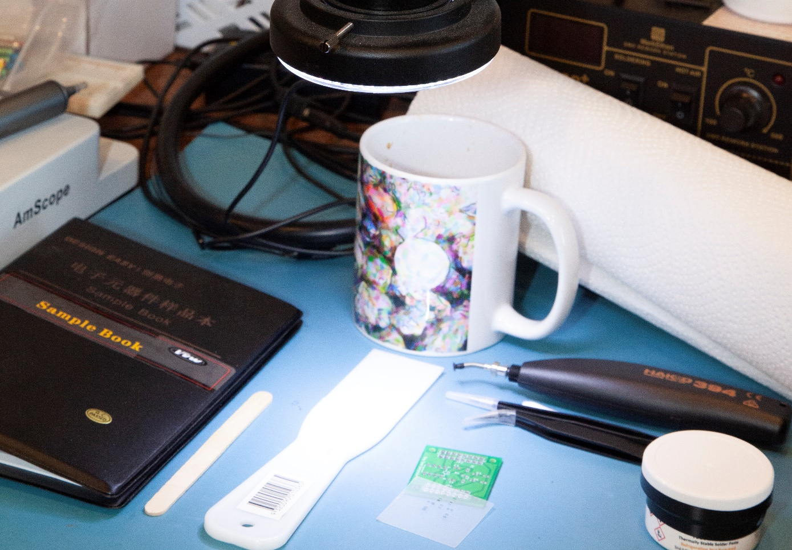

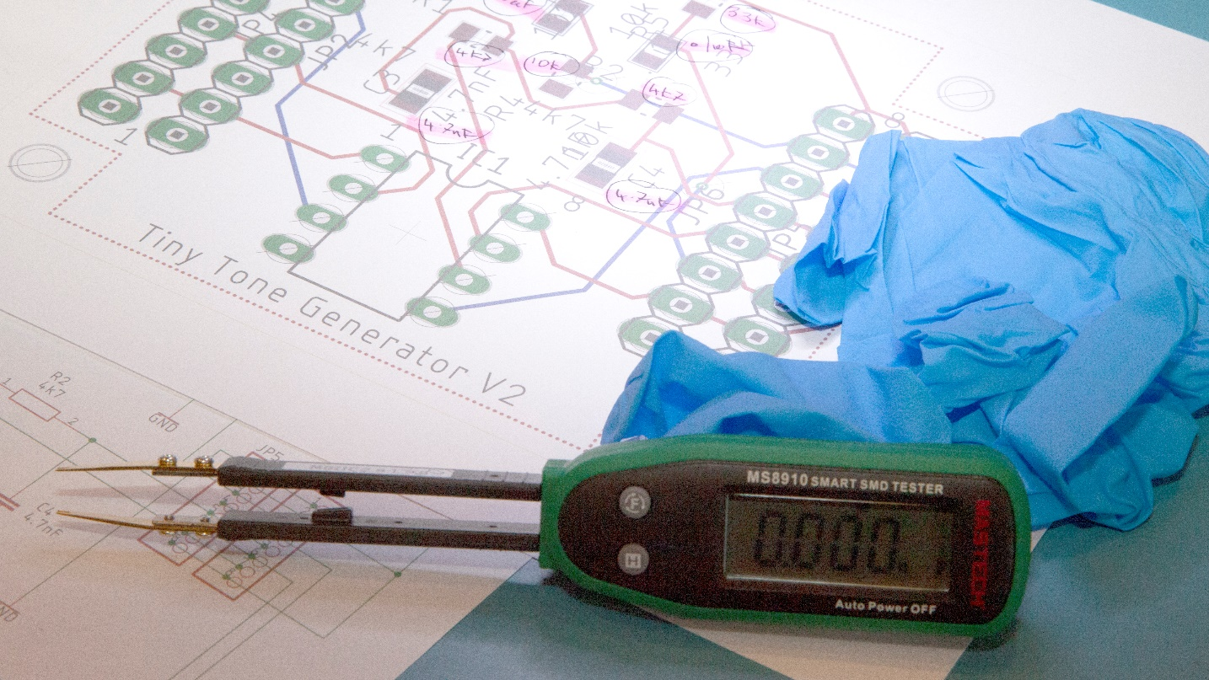

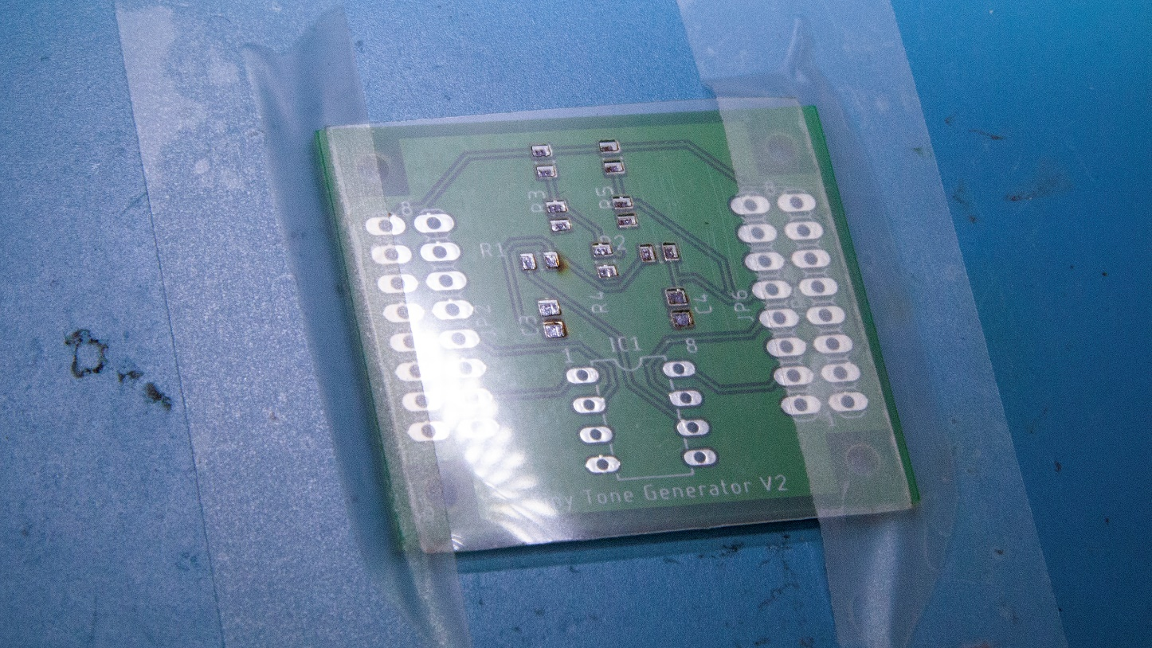

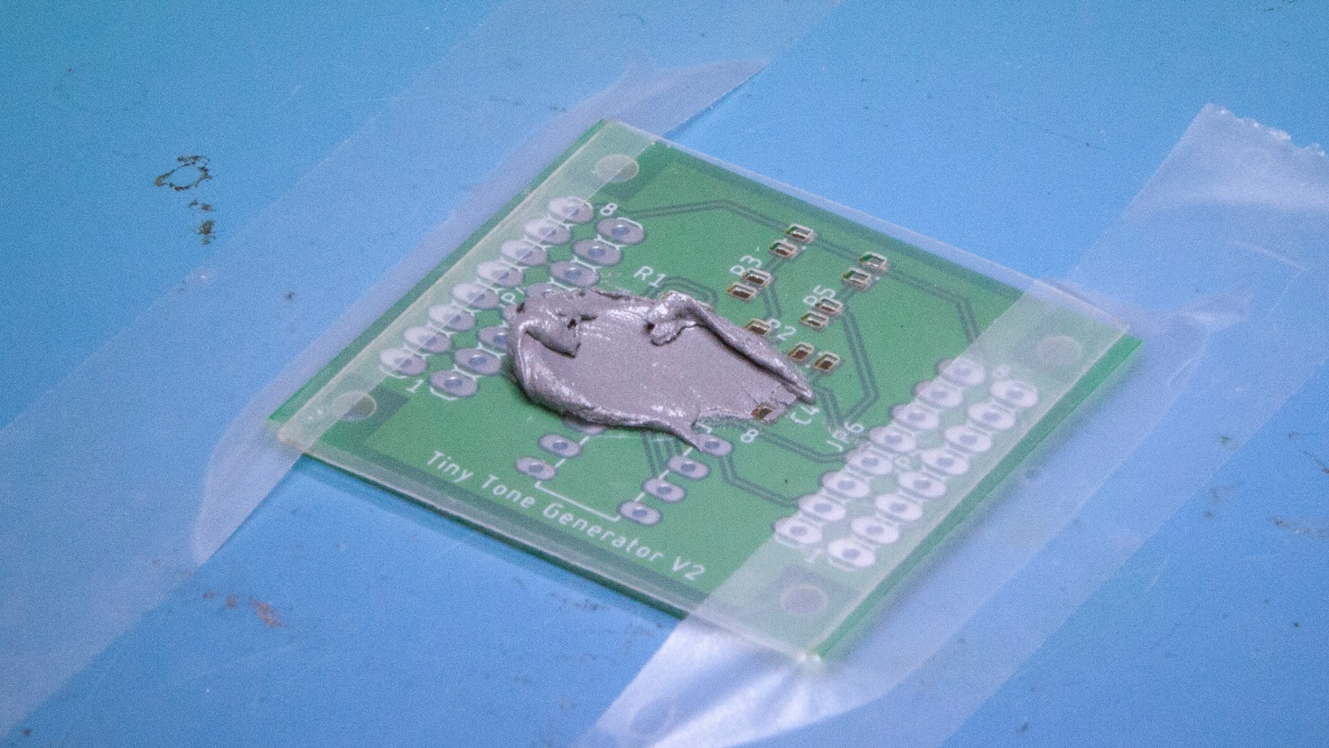

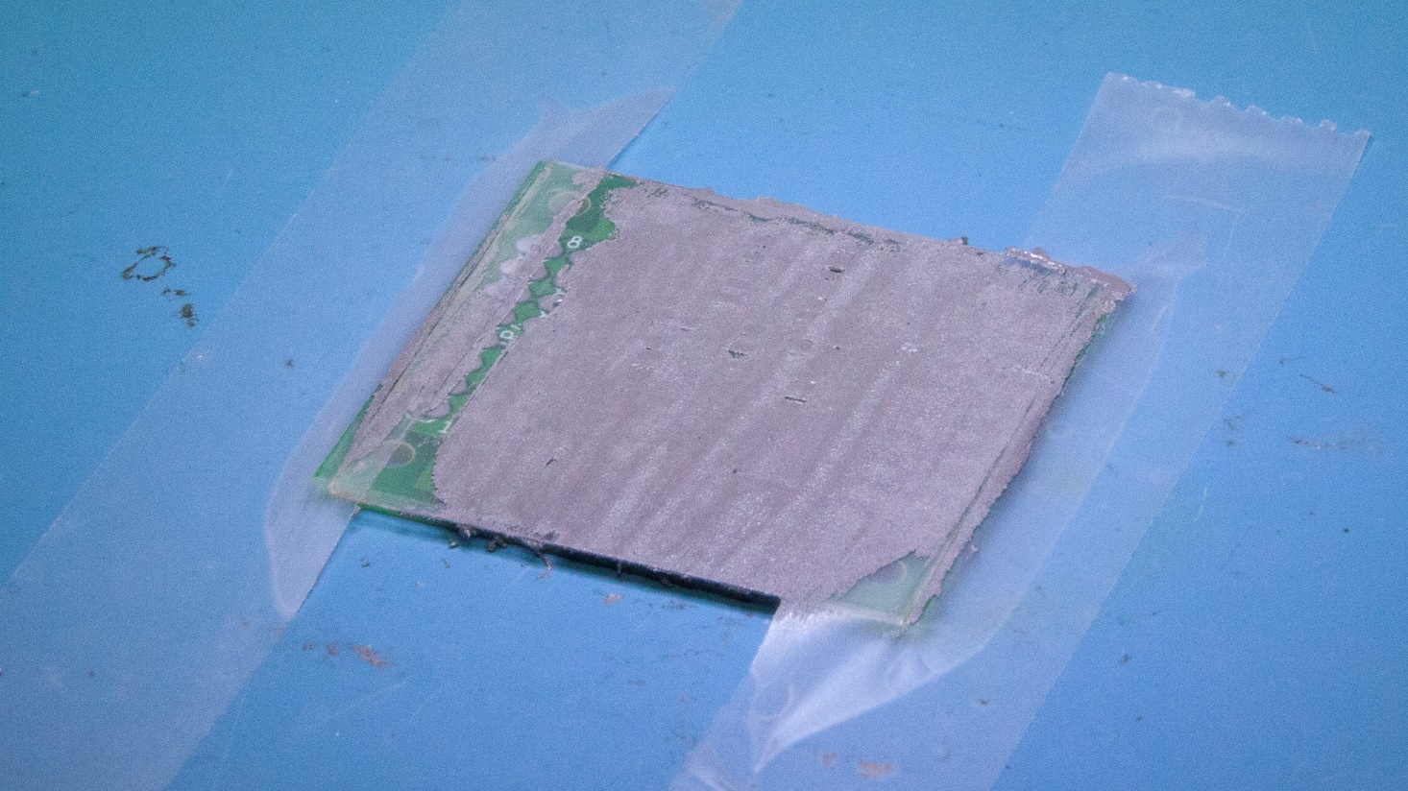

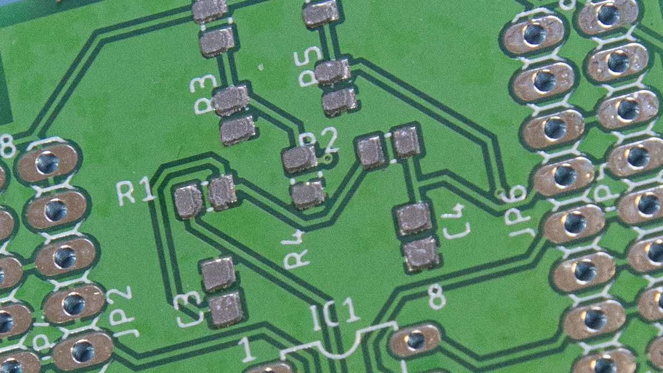

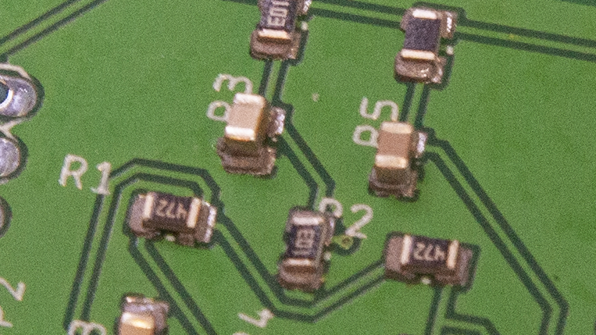

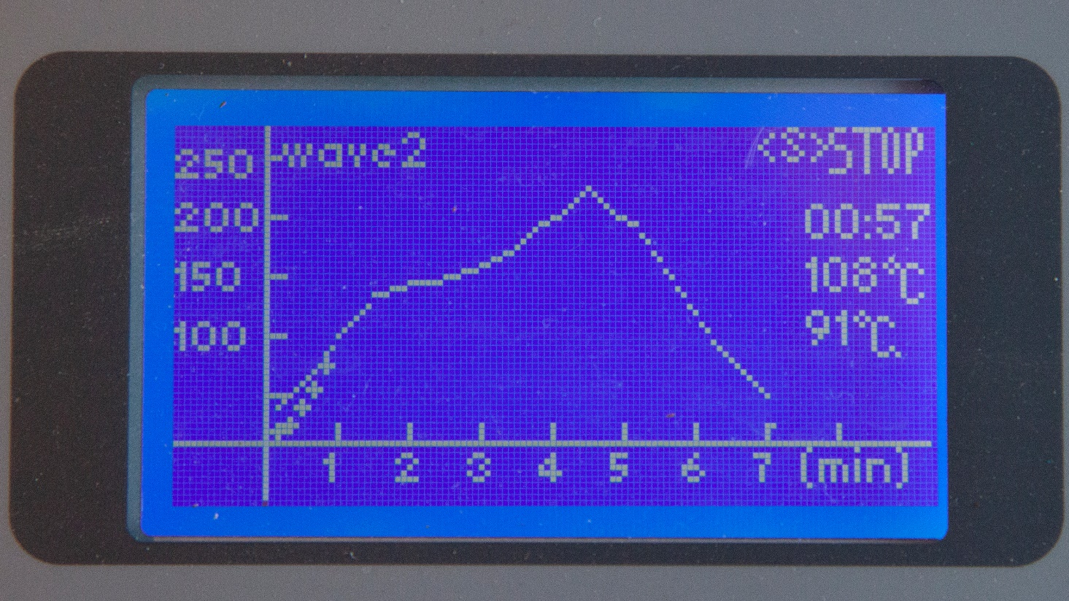

Solder Oven links: - Check that you purchase the 1500W, 230V version. <https://www.aliexpress.com/wholesale?catId=0&initiative_id=AS_20190808195053&origin=y&SearchText=puhui+t-962a&switch_new_app=y>

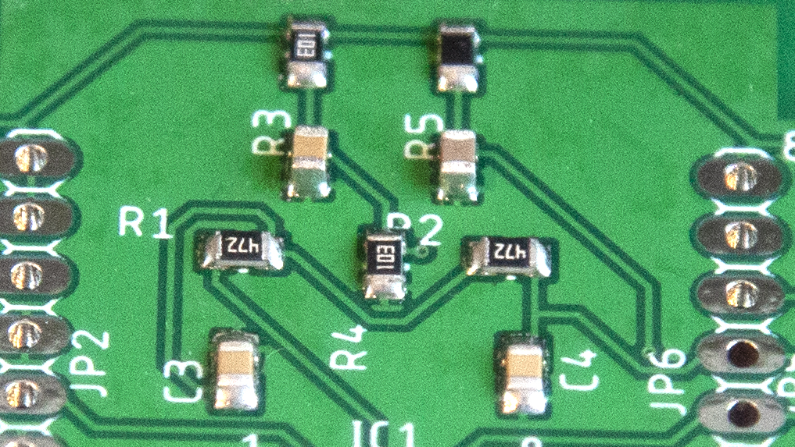

* 1. Notes on Solder Masks / Stencils
     1. Most fabricators make them. See Seeed and Polou for examples.
     2. Much cheaper these days – start under USD$10.
     3. Can make them in mylar with a laser cutter
     4. Method is based on exporting the cream layer from Eagle and using it to make an SVG or gerber file for the laser cutter. See the Glowforge example below. The details require knowledge of the target laser cutter.
     5. There is a sample solder mask on GitHub. It is a standard vector graphics file (.svg) ToneGeneratorSMD_V1_SolderMaskplain.svg

<https://www.pololu.com/product/446>

<http://support.seeedstudio.com/knowledgebase/articles/466664-fusion-pcb-stencil-specification>

<https://www.autodesk.com/products/eagle/blog/getting-started-solder-paste-stencils/>

<https://community.glowforge.com/t/how-to-create-a-pcb-stencil/17447>

1. Getting a board assembled
   1. Generate Gerber File

<http://support.seeedstudio.com/knowledgebase/articles/1176949-how-to-generate-gerber-and-drill-files-from-eagle> .

* 1. Generate Pick and Place Files <http://support.seeedstudio.com/knowledgebase/articles/1911202-how-do-i-export-pcb-pick-and-place-xy-files-for>
  2. Generate Assembly Files

<http://support.seeedstudio.com/knowledgebase/articles/1911127-how-do-i-export-pcb-assembly-drawings-fabrication>

<https://www.seeedstudio.com/blog/2019/06/12/how-to-generate-assembly-files-and-why-they-are-important/> *

* 1. The process uses some cool equipment

<https://www.seeedstudio.com/blog/2019/07/10/9-must-know-pcb-assembly-pcba-equipment/>

* 1. Upload to the Website

<https://www.seeedstudio.com/free-assembly-for-5-pcbs.html>

1. … and finally – a few notes on programming the ATTINY

From the blog:

### “Compiling the program

I compiled the program using Spence Konde's ATTiny Core [[5]](http://www.technoblogy.com/show?20W6#cite_note5). Choose the **ATtiny25/45/85** option under the **ATtinyCore** heading on the **Board** menu. Then choose **Timer 1 Clock: CPU**, **B.O.D. Disabled**, **ATtiny85**, **8 MHz (internal)** from the subsequent menus. Choose **Burn Bootloader** to set the fuses appropriately. Then upload the program using ISP (in-system programming); I used Sparkfun's Tiny AVR Programmer Board; see [ATtiny-Based Beginner's Kit](http://www.technoblogy.com/show?NMX).

Here's the whole Tiny Function Generator program: [Tiny Function Generator Program](http://www.technoblogy.com/list?21NB). “

<https://www.sparkfun.com/products/11801>

<https://learn.sparkfun.com/tutorials/tiny-avr-programmer-hookup-guide>